POWER BI TOOL
Task :
Prepare a document with details of the following along with their price
− Power BI Desktop
− Power BI Pro
− Power BI Premium

Power BI is a business analytics service by Microsoft. It aims to provide interactive visualizations and business intelligence capabilities with an interface simple enough for end users to create their own reports and dashboards.
Power BI comes in three levels – Desktop, Pro, and Premium. The Desktop level is free for individual users, while the Pro plan costs $9.99 per user per month. The Premium plan starts at $4,995 a month per dedicated cloud compute and storage resource
Microsoft Power BI is a cloud-based business intelligence and analytics service that provides a full overview of your most critical data. Connecting to all of your data sources, Power BI simplifies data evaluation and sharing with scalable dashboards, interactive reports, embedded visuals and more.

Power BI Desktop
Power BI Desktop is a free application that can be installed on local computer that allows to connect , transform, and visualize the data. With Power BI Desktop, multiple different sources of data can be connected, and combine it (often called modeling) into a data model. This data model allows to build visuals, and collections of visuals that can be shared as reports, within the organization. Most users who work on business intelligence projects use Power BI Desktop to create reports, and then use the Power BI service to share their reports with others.
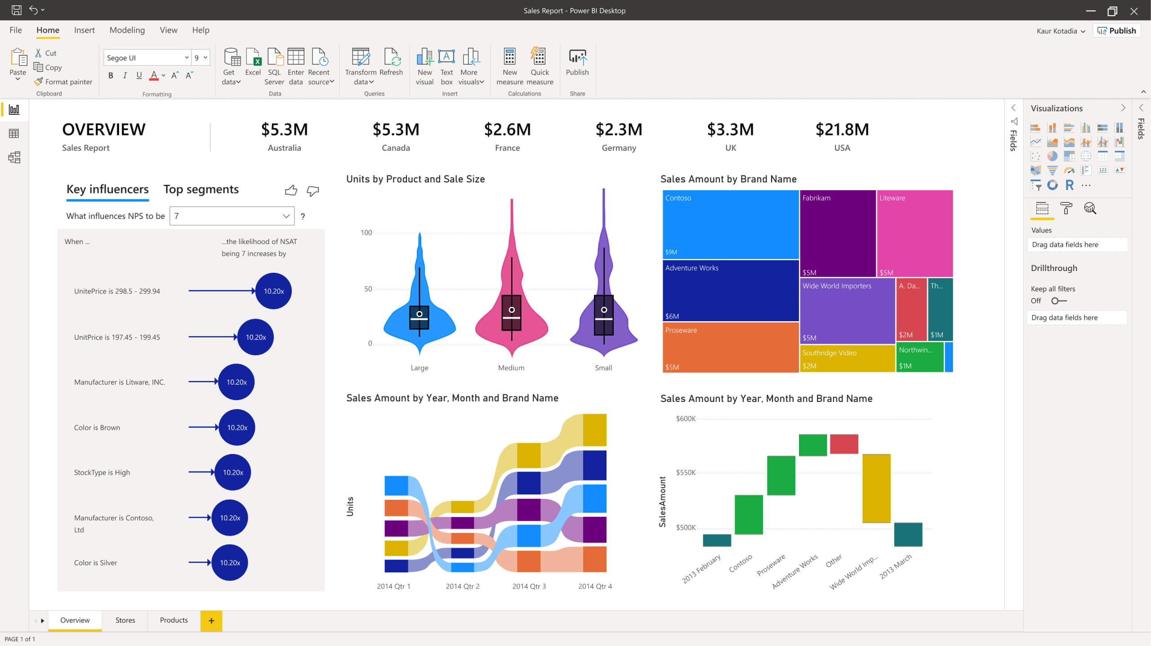

Following are the system requirements to download Power BI tool –
Supported Operating Systems
- Windows 10, Windows 7, Windows 8, Windows 8.1, Windows Server 2008 R2, Windows Server 2012, Windows Server 2012 R2
- Microsoft Power BI Desktop requires Internet Explorer 9 or higher
- Microsoft Power BI Desktop is available for 32-bit (x86) and 64-bit (x64) platforms
Users can select a language in which they want to install Power BI and following files are available for download.
This is the link to directly download Power BI files –
https://www.microsoft.com/en-us/download/details.aspx?id=45331
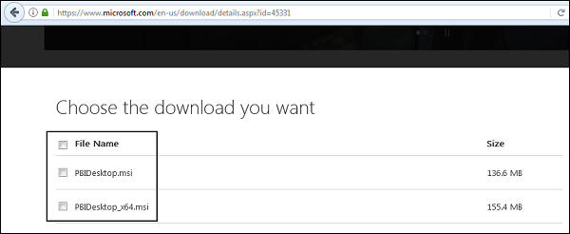
PBIDesktop_x64.msi shows a 64-bit OS file. Select the file need to install as per OS type and click Next. Save the installation file on the local drive.
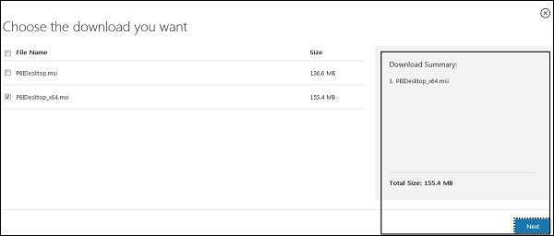
When we run the installation file, following screen is displayed.
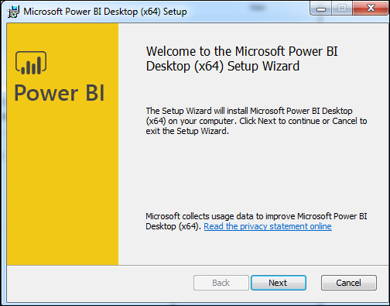
Accept the license agreement and follow the instructions on the screen to finish the installation.
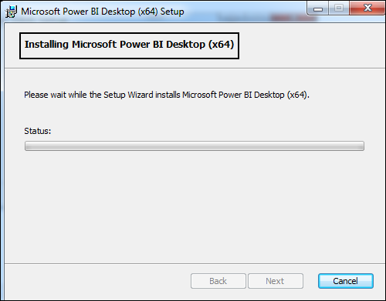
When Power BI is installed, it launches a welcome screen. This screen is used to launch different options related to get data, enrich the existing data models, create reports as well as publish and share reports.
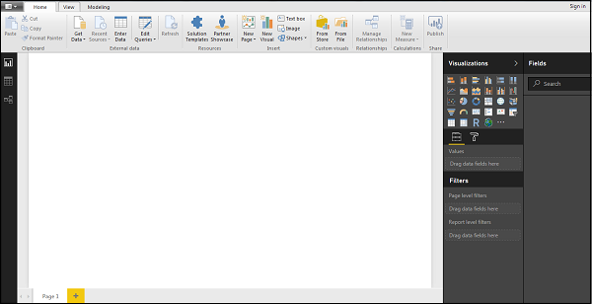

The most common uses for Power BI Desktop are as follows:
- Connect to data.
- Transform and clean that data, to create a data model.
- Create visuals, such as charts or graphs, that provide visual representations of the data.
- Create reports that are collections of visuals, on one or more report pages.
- Share reports with others by using the Power BI service.

There are three views available in Power BI Desktop, which is available on the left side of the canvas. The views, shown in the order they appear, are as follows:
- Report: In this view, reports and visuals can be created , where most of the creation time is spent.
- Data: In this view, tables can be seen, measures, and other data used in the data model associated with the report, and transform the data for best use in the report's model.
- Model: In this view, it can used to view and manage the relationships among tables in the data model.

People most often responsible for such tasks are often considered data analysts (sometimes referred to as analysts) or business intelligence professionals (often referred to as report creators). However, many people who don't consider themselves an analyst or a report creator use Power BI Desktop to create compelling reports, or to pull data from various sources and build data models, which they can share with their coworkers and organizations.

Power BI Pro
Power BI Pro is an individual user license that lets users read and interact with reports and dashboards that others have published to the Power BI service. Users with this license type can share content and collaborate with other Power BI Pro users. Only Power BI Pro users can publish or share content with other users or consume content that's created by others, unless a Power BI Premium capacity hosts that content.
the Pro plan costs $9.99 per user per month.

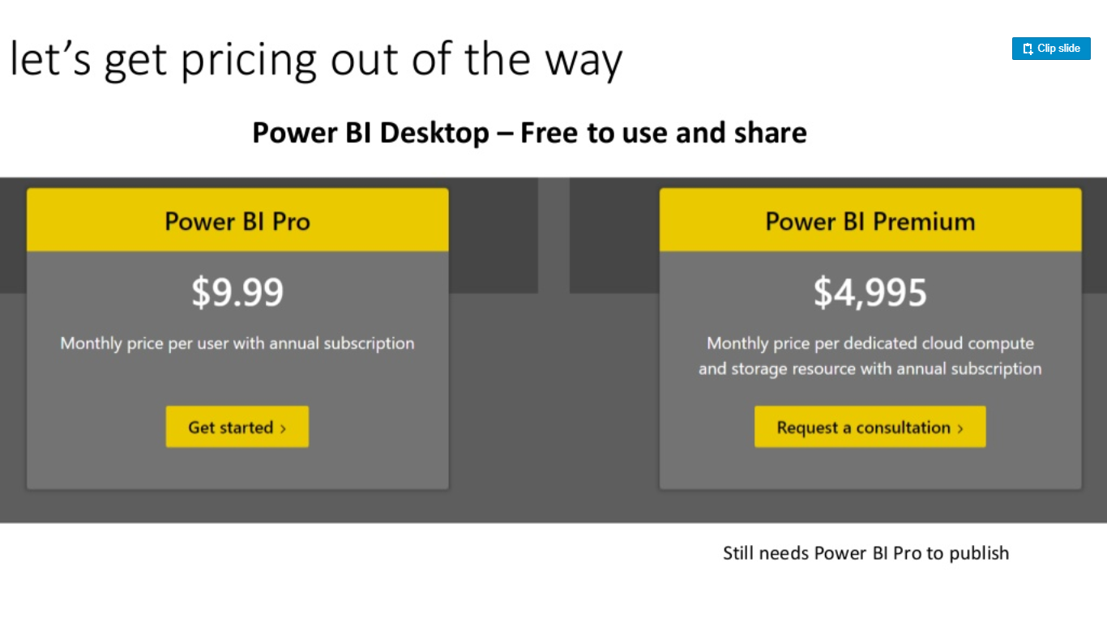

Purchase Power BI Pro user licenses
Herewith mentioned instructions, explains how to buy Power BI Pro user licenses in the Microsoft 365 admin center. After purchasing licenses, it is possible to assign them to users in either the Microsoft 365 admin center or the Azure portal.

Prerequisites
To purchase and assign licenses in the Microsoft 365 admin center, one must be a member of the global administrator or Billing administrator role in Microsoft 365.
To assign licenses in the Azure portal, one must be an owner of the Azure subscription that Power BI uses for Azure Active Directory lookups.

Purchase licenses in Microsoft 365
Follow these steps to purchase Power BI Pro licenses in the Microsoft 365 admin center:
- Sign in to the Microsoft 365 admin center.
- On the navigation menu, select Billing > Purchase services.
- Search or scroll to find the subscription required to buy. Will get to find Power BI under Other categories that might interest that near the bottom of the page. Select the link to view the Power BI subscriptions available to the organization.
- Select Power BI Pro.
- On the Purchase services page, select Buy.
- Choose Pay monthly or Pay for a full year, according to how he/she want to pay.
- Enter the number of licenses to buy based on the number of users required, then select Check out now to complete the transaction.
- To verify purchase, go to Billing > Products & services and look for Power BI Pro.
- To add more licenses later, locate Power BI Pro on the Products & services page, and then select Add/Remove licenses.
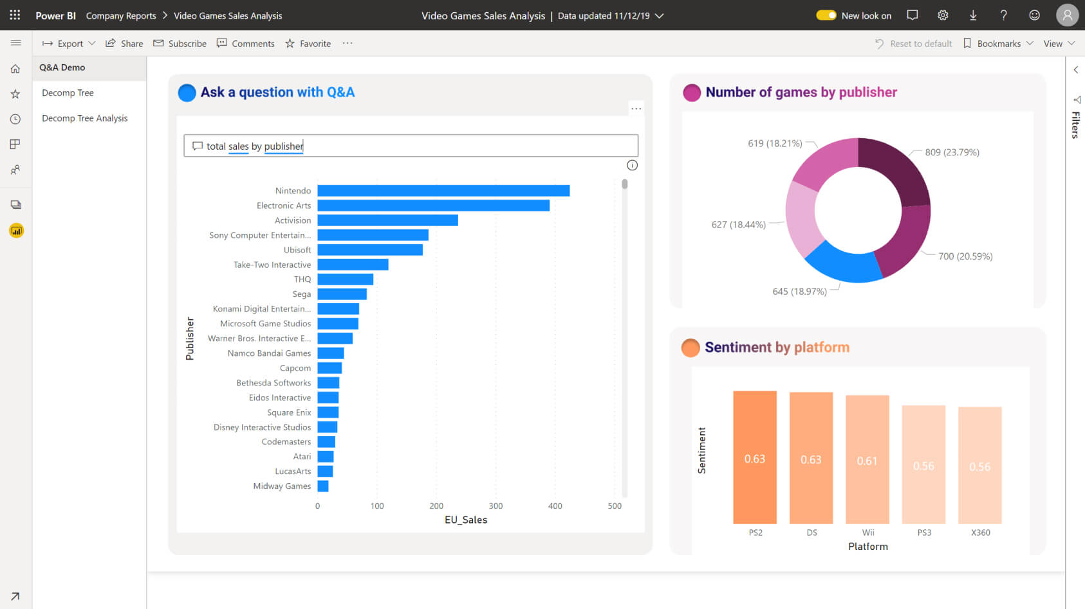

Assign licenses in the Microsoft 365 admin center
For information about assigning licenses in the Microsoft 365 admin center, see Assign licenses to users.
For guest users, see Assign licenses to users on the Licenses page. Before assigning Pro licenses to guest users, contact Microsoft account representative to make sure the compliance with the terms of the agreement with Microsoft.

Assign licenses in the Azure portal
Follow these steps to assign Power BI Pro licenses to individual user accounts:
- Sign in to the Azure portal.
- Search for and select Azure Active Directory.
- Under Manage on the Azure Active Directory resource menu, select Licenses.
- Select All products from the Licenses - Overview resource menu, then select Power BI Pro to display the list of licensed users.
- From the command bar, select + Assign. On the Assign license page, first choose a user, then select Assignment options to turn on a Power BI Pro license for the selected user account.

Power BI Premium
Power BI Premium is a capacity-based offering that includes: Flexibility to publish reports broadly across an enterprise, without requiring recipients to be licensed individually per user. Greater scale and performance than shared capacity in the Power BI service.

Power BI Premium: The Premium plan starts at $4,995 a month per dedicated cloud compute and storage resource.
Power BI Premium provides dedicated capacity to deliver more consistent performance and support larger data volumes in Power BI. Power BI Premium also enables widespread distribution of content by Pro users without requiring users who view the content to have Power BI Pro licenses.
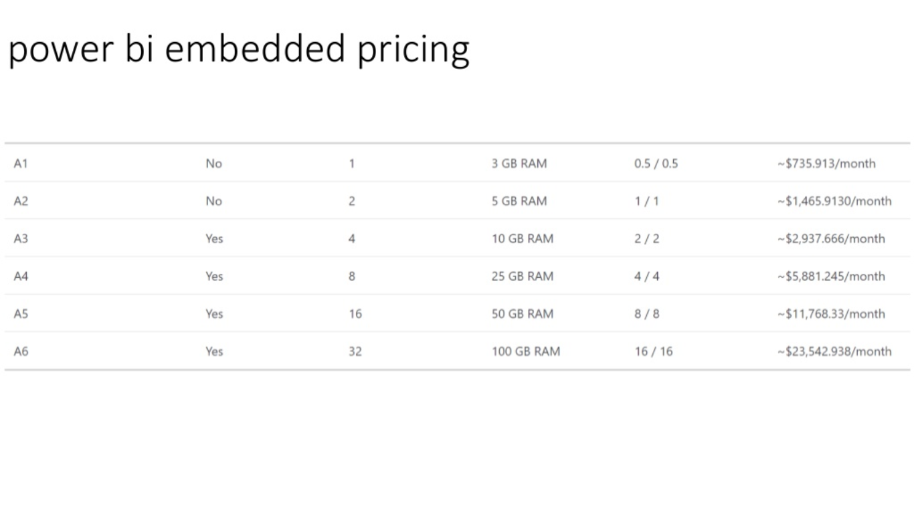

All things being equal, when is power bi premium worth it? Well, at the lowest tier.
- 500 users who view reports in the portal. $10 per user per month.
- 1,000 users who view: $5 per user per month.

Dedicated capacity
- The Power BI Service (Portal) is a shared resource.
- Makes performance inconsistent
- Cheaper
- Power BI premium means having your own Power BI server, with dedicated compute (CPU) and memory.
- Surprises me that people who spend $250,000 in SQL Server licensing complain about Power BI Premium costs.

Early use of new features
Microsoft has started that features will be released in Power BI Premium before Power BI Professional. This could be considered a huge competitive advantage.
Embedding
Power BI Premium allows for embedding Power BI into a custom applications.
- Pausable
- Billable hourly
- Cheaper
- No Power BI Service (Portal) for viewers
- Deploy to SharePoint or a custom portal written by developers.
